**CHAPTER ONE**

**INTRODUCTION**

**1.1 BACKGROUND INFORMATION**

From the inception of the world to this present day, Trading and commerce has metamorphosed into different forms. The evolution of trading has taken a long walk over the past thousands of years from barter to e-commerce. E-commerce, also known as electronic commerce is simply the buying and selling of products over the internet (Anjali, 2014) , Oftentimes involving the transfer of funds and payments for these products over the internet. As simple as this may sound, e-commerce has revolutionalized the global economy of different nations positively.

Before the advent of e-commerce, businesses could only conduct commercial transactions physically thereby limiting the scope of their business since the working hours and customer reach was limited. The emergence of the e-commerce technology has forced many companies to embrace technology and dive into the online market (Silviu, 2010). Big players in the e-commerce industry like Amazon, eBay, and Rakuten generate billions of dollars in annual revenue (Geri, 2022). Statistics even shows that the annual revenue for these mega companies never stays the same as it keeps up-surging every year.

Popular e-commerce Unicorn, Amazon has succeeded in growing its number of employees from 250,000 in 2015 to 1,608,000 in 2021 (Coppola, 2022). For an e-commerce business to strive, It has to put certain factors in place to retain the attention of customers when they visit the online store. One of such factor is the user experience.

Exceptional e-commerce stores standout by ensuring they optimize customer experience to retain customer attention on the online store (Bonastre, 2014). The more time a customer spends on the store, the more products they are likely to purchase. Excellent customer experience ensures navigating the online store to find products on the store is as easy and stress-free as possible. But this is not always enough for customers.

Online shoppers like to take certain measures to ensure they are purchasing products at the most optimal price possible. Research by oberlo.com indicates that more than 81% of online shoppers compare prices from multiple e-commerce stores before making any purchase. This is known as online price comparison.

Online price comparison is the act of comparing the prices and features of products from a number of e-commerce stores in order to make optimal decisions when shopping online. Price comparison is not limited to online shoppers alone. e-commerce platforms compare prices from competitors and use that data to set prices for their own products. This process is called competitive pricing. A scenario where ecommerce stores spy on their competitor’s pricings and decide to sell at a slightly lower price than their competitors to attract customers or sell at a slightly higher price than their competitors to attract higher profits (Blanckenberg, 2022). Competitive pricing is no easy-breezy task as employees will need to manually compare products and prices for thousands of products and then update accordingly on their e-commerce website.

The evolution of price comparison tools will shift the bargaining power to the customers as online stores will engage in competition to present their products at the most optimal price, since customers can now identify price details from multiple websites at a glance. This will lead to an increase in price competition between ecommerce stores, causing price of items to drop significantly. Ecommerce stores with prices too high will find it difficult selling to customers (Shin, 2001)

The 21st century has encountered a massive surge in task automation in diverse sectors and industries and the e-commerce sector cannot be left out (Vikram, 2020). Sourcing data for analyzing the e-commerce market and price comparison can be very boring and stressful, and it is for such operations that task automation should be implemented. Data from multiple e-commerce stores can be extracted automatically by a method called web scraping (Cem, 2022).

Web scraping is the automated harvesting or extraction of data from websites. This data can further be used for data analytics and research, replicating web contents and monitoring trends. Price comparison engines automatically extract data from e-commerce stores using web scraping . The data retrieved from these e-commerce stores is then used to compare products price and features for making optimal decisions when shopping online (Kasereka, 2021).

Websites like pricepirates and google shopping have been able to develop price comparison web applications to tackle this challenge but pricepirates have only succeeded in building a web application with a very poor user interface, while google shopping app has been terminated to use google search as its default, making it even more difficult to compare prices. (Ron, 2021)

**1.2 STATEMENT OF THE PROBLEM**

Research by oberlo.com shows that more than 81% of customers compare product prices from multiple e-commerce websites before proceeding to purchase the product from the most price optimal store.

This comparison between multiple e-commerce stores can be stressful and frustrating as customers will have to shuffle between multiple tabs or e-commerce websites to perform price comparison for products, leading to a bad customer experience and bad customer experience results to lower or even zero purchase.

This project aims to design and build a web scraper tool for e-commerce stores. The web application scrapes product data from multiple e-commerce websites, displays the product and its price to the user in an intuitive web interface for stress-free price comparison between e-commerce stores. The web application also scrapes and displays hot and flash sales from multiple websites in a single page without the need for the user to visit multiple ecommerce stores.

This will eliminate the need to manually switch between tabs of e-commerce websites to compare the price of products hence, delivering better user experience thus leading to more products purchased. A win-win scenario for e-commerce stores and customers accordingly as customers get better shopping experience with ease and the e-commerce stores make more sales effortlessly.

To aid developers, the project further builds an API for developers to easily gain access to its robust functionalities. The API returns scraped data in JSON format for developers to utilize as they deem fit.

**1.3 AIM AND OBJECTIVES OF STUDY**

The aim of this project is to design and build a web scraper tool for e-commerce websites to effectively and easily perform price comparison for optimal online shopping

The objectives for the project are as follows:

**Objective 1:** To review and study already existing web scraper tools and price comparison web applications.

**Objective 2:** To build a web scraping tool for scraping data from multiple e-commerce websites.

**Objective 3:** To design and build an intuitive web application for the scraping tool.

**Objective 4:** To implement, test and deploy the web application.

**Objective 5:** To build an API for developers to interact with the application.

**1.4 METHODOLOGY**

In order to complete the full-fledged application that will efficiently meet up with all the aim and objectives of this project, the following methodologies were duly followed:

Table 1.1 Methodology and Tools

|  |  |  |
| --- | --- | --- |
| OBJECTIVES | METHODOLOGY | TOOLS |
| **Objective 1:** To review and study already existing web scraper tools and price comparison web applications | In order to carry out an effective research on already existing web scraper tools and price comparison web applications, popular price comparing engines like google shopping, pricespy, intelligencenode, pricebat and pricepirates will be thoroughly studied. What services they offer, How they operate, their functionalities, credits, downsides and limitations. | Google and online price comparison web applications |
| **Objective 2:** To build a web scraping tool for scraping data from multiple e-commerce websites. | Python’s popular web scraping library called beautiful soup was used to build the web scraping tool. | Python and Beautiful soup |
| **Objective 3:** To design and build an intuitive web application for the scraping tool. | To obtain a robust and functional application, the web scraper tool will be integrated into a web application with an intuitive frontend interface built using HTML, CSS and JAVASCRIPT.  The backend of the web application will be built using the Django web framework. | HTML, CSS, Javascript, Python and Django |
| **Objective 4:** To implement, test and deploy the web application. | In order to effectively debug this project, The web application will be tested before deployment. Python’s library for automated testing called unittest will be used to achieve this feat before deploying the web scraping application to pythonanywhere. | Unittest and pythonanywhere |
| **Objective 5:** To build an API for developers to interact with the application. | Django rest framework will be used to build a robust API for the web application. | Django rest framework and JSON. |

**1.5 SIGNIFICANCE OF THE STUDY**

This project is highly relevant because it benefits both the online shoppers and e-commerce stores alike. With this project in place, online shoppers can now easily compare prices from their favorite e-commerce stores with just a few clicks without having to switch back and forth between multiple tabs.

The web scraping application rids users of shopping stress and boosts customer shopping experience by getting the best deals available by automating online price comparison (Shalini, 2022). Customers can easily make optimal shopping decisions while e-commerce stores get to make more sales as a result, since impressive customer experience is directly proportional to purchases made.

E-commerce stores can also use the web scraping tool to monitor price fluctuations in their competitor’s online store. They can use that data as a standard for pricing their own product by selling slightly higher to make more profit, or slightly lower to attract more sales.

This project also focuses on building an API with multiple endpoints. With this API, developers can easily integrate the functionalities of the web application into their own application without having to code these features from scratch. Developers can simply make API calls to the web scraper application and get JSON data returned to them.

The web application also scrapes and displays all hot deals and flash sales from multiple e-commerce stores, this way, users can view all the hot and recommended deals from their favorite e-commerce stores all in one page without having to visit multiple websites for this data.

The project aims to automate and ease the process of e-commerce price comparison by building a web scraping tool with a topnotch web user interface. The web scraping tool is also focused on delivering better customer shopping experience.

**1.6 SCOPE OF THE STUDY**

1. The web application scrapes data from only three e-commerce websites namely Jumia, Konga and Kaiglo.
2. The web application scrapes only four product categories namely phones and tablets, consumer electronics, fashion wears and computers

**1.7 LIMITATION OF THE STUDY**

Some of the limitations of the project are as follows:

1. The web scraper application is limited to conduct only price comparison for products and not overall category comparison.
2. The web scraper application is ideal for individuals and medium scale e-commerce businesses since the items and categories covered for price comparison is limited.

**1.8** **PROJECT OUTLINE**

Chapter One of the project is the introduction of the project. It contains the Background information, statement of the problem, aim and objectives of the study, methodology, significance of the study, limitation of the study and the project outline.

Chapter Two of the project represents the Literature Review. This section mentions and discusses antecedent thesis, research and articles related to the project. The literature review also analyzes pre-existing attempts to solve the problems this project attempts to tackle.

Chapter Three of the project is the system analysis and design. This chapter gives a description of the application design, system requirements and system architecture.

Chapter Four of the project is the system implementation. This chapter explains the modus operandi of the web scraper tool and its components, algorithms, libraries, frameworks and the user interface.

Chapter Five is the summary, recommendation and conclusion of the project

**CHAPTER TWO**

**LITERATURE REVIEW**

**2.1 INTRODUCTION**

A web scraping tool is a software that is used to scrape, mine or extract data from websites. Collecting data from websites can be done manually by users, but this process becomes really hectic and almost impossible when it involves the extraction of enormous data. Web scrapers, also known as web crawlers help to automate this data collection process from websites by crawling through web pages. Web scraping libraries like beautiful soup scrapes HTML or XML documents and have appropriate python functions available for searching, traversing and modifying the HTML or XML tree to extract the desired data (Zhao, 2017). Companies and businesses need to feed on enormous amount of data to be able to identify trends, gain insight, predict outcomes, study the behavioral pattern of customers, identify business opportunities and strategically position themselves far ahead of their competitors.

Before the advent of web scraping, Sourcing data has always been a tremendous challenge to businesses who are constantly in dire need of bulky data to gain business insights. Web scrapers have made it easy to spy the websites of competitors, in order to make strategic decisions. In this project, we utilize web scraping to extract data from ecommerce websites in order to effectively conduct price comparison for optimal online shopping. This tool will boost the user experience during online shopping as users will not be over worked about making the decision of the most optimal online store to purchase a product. The online comparison application alleviates the stress of choice making by presenting the prices for a given product from different stores in a single intuitive web page.

**2.2 HISTORY OF WEB SCRAPING**

The world wide web was created by Tim Berners Lee in the year 1989 and shortly after, the first web scraper called “The Wanderer” was created by Mathew Gray in June 1993. The Wanderer was created for the sole aim of measuring the size of the web. After the invention of “The wanderer”, scientists were inquisitive and zealous to use this new technology of web scraping to power ideas and create solutions, Hence it did not take long before the first crawler-based web search engine called Jumpstation was launched that same year.

In the year 2000, salesforce and ebay launched a API crawler with which developers could gain access to their website’s data and functionalities. This caused a new revolution of web APIs as most other companies followed suit.

Web scraping has taken several forms since its invention. The first form of web scraping was manual copy-and-paste. This was done manually by humans and is not ideal for harvesting big data. Manual copy-and-paste technique of data scraping is very slow and prone to error since the procedure is not automated and is conducted by humans. Web scraping with time metamorphosed to include other techniques like regular expressions also known as pattern matching, HTML parsing and DOM parsing.

**2.3 PRESENT DAY WEB SCRAPING**

Web scraping has taken a new face over the years. A technology that started as basic manual copy-and-paste has now evolved into an innovation that has powered millions of businesses and startups. The major aim of web scraping is to extract data from websites. As the size of data to be extracted grew to become enormous, human copy-and-paste and basic regular expression could no longer serve for scraping data as this meant massive man-power and time would be required to extract meaningful amount of data.

Present day web scraping has evolved into an automated process. The abundant libraries for web scraping has also contributed positively to this evolution. In this present era, web scraping has proven its relevance in data analysis, marketing, leads generation and price monitoring. Scraped data is usually saved in an excel spreadsheet or CSV while sophisticated scrapers will integrate support for other data formats such as JSON which can then be used in APIs.

**2.4 WEB SCRAPING AND ECOMMERCE**

Web scraping has pushed a lot of businesses into the limelight due to its vast use cases. There are different types of web scraping and each type has its unique role to play in the business sector. It is no longer news that businesses with great infrastructure will do well but businesses that position technology and innovation at the forefront will stay far ahead of its competitors. Web scraping has proven to be a vital strategy for e-commerce businesses to obtain rich data and customer insights. (Kasereka, 2021)

E-commerce stores constantly need to spy on competitors to make moves due to the competitive nature of the e-commerce sector. This frequent monitoring gets really difficult and sometimes impossible when the frequency and degree of monitoring gets really high. E-commerce businesses cannot efficiently conduct price monitoring manually and this is where automated web scraping comes in to play.

**2.4 REVIEW ON EXISTING SYSTEMS**

There are a number of web applications that use web scraping to monitor and compare the prices of products from ecommerce stores. Some of these applications make money by referring customers to online stores after comparison.

**2.4.1 PRICESPY**

Pricespy(pricespy.co.uk) is a web and mobile application that utilizes web scraping and data feed to compare prices and products from over 6100 shops. The app has a nice and easy to use interface that makes it easy for customers to navigate and compare products online. Pricespy is absolutely free for customers but charge a certain fee from shops each time a customer is redirected to these online shops from their website. Pricespy updates product price three to five times daily to avoid the shop websites blocking their web crawlers.

The mobile application of pricespy can be downloaded on Google play store. Google playstore is a store where users can download games, apps and digital contents for their android devices. App ratings and reviews are also displayed on the platform to guide users on the best apps to use. Pricespy has ranked greatly on google playstore bagging over 1 million downloads.

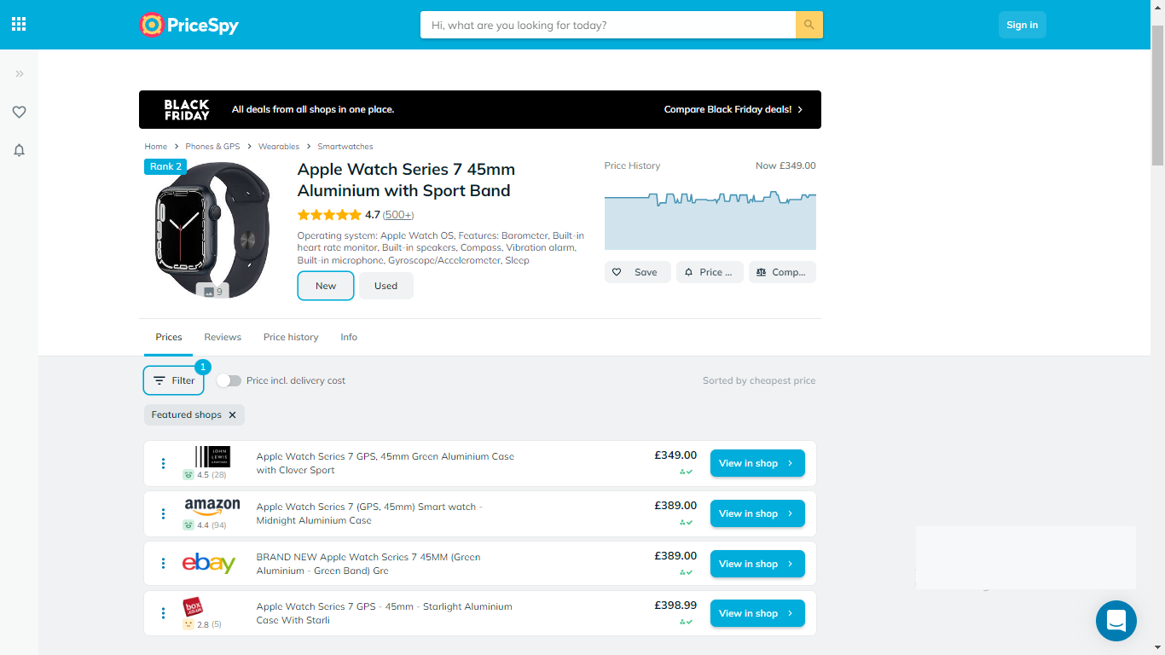

Figure 2.1 Image displaying the web interface of pricespy

(Source: pricespy.co.uk)

Some of the features of Pricespy include:

1. **Multiple Shops:** Compare product prices across 6100 shops. This way customers can make optimal shopping decisions
2. Product reviews and comments
3. **Price History:** View the price trend in a graphical format. This feature will show users how the price for a particular product has changed over time
4. **Save Product:** Discovered products can be saved and processed later.
5. **Multilingual:** Website can be viewed in English, French, Norwegian, Danish, Finish and others.
6. **Price Notification:** Users get notified when the product price drops to your desired price.

**2.4.2 Yahoo Shopping**

Yahoo shopping is an online comparison tool that compares price, track price changes and scrapes deals from online shops for optimal shopping. Yahoo shopping redirects customers to merchant websites but earn a small fee from these referral links. This platform displays products from a wide variety of shops and product categories to promote the satisfaction of customers.

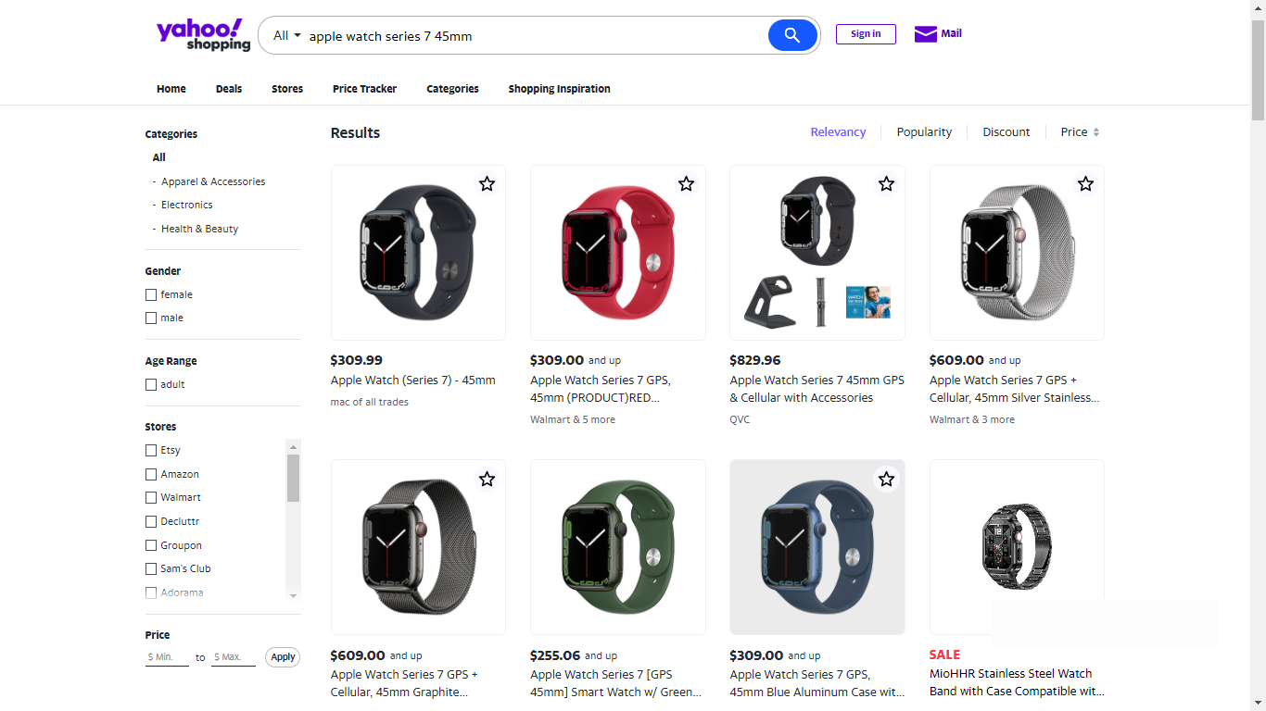

Figure 2.2 Image displaying the web interface of yahoo shopping

(Source: shopping.yahoo.com)

Some of the features of yahoo shopping include:

1. **Multiple Shops:** Compare product prices across multiple shops. This way customers can make optimal shopping decisions
2. **Price Tracker:** This feature tracks the price of products added to wishlist and send an alert when the price drops.
3. **Advanced search filter:** Product search can be trimmed down by setting criteria for products to be indexed such as maximum and minimum price. When a price filter is applied, only products within that price range will be displayed to the user.

**2.4.3 Shopbot.com**

Shopbot is an online comparison engine that uses web scraping to perform price analysis and compare products based on their price, reviews and features. Shop bot is an Australian company that conducts product comparison across products of diverse categories. Prices on the platform are updated daily but the final price on the merchant’s website could sometimes be slightly different from that on the comparison website as price updating is not implemented frequently.

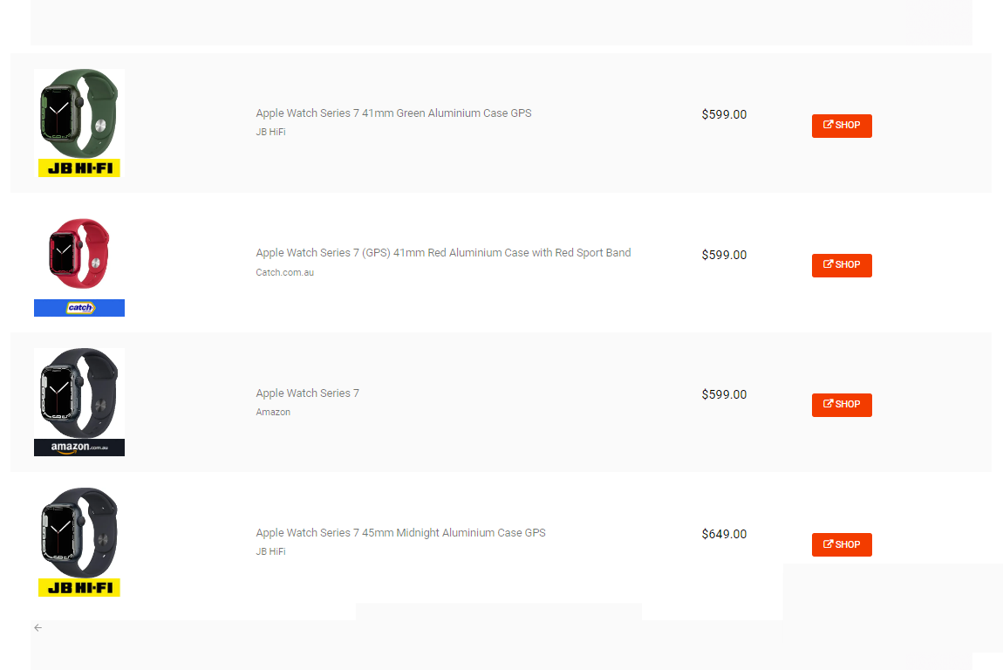

Figure 2.3 Image displaying the web interface of Shopbot

(Source: shopbot.com.au)

Some of the features of Shopbot include:

1. **Vast Product Categories:** Availability of vast product categories. The platforms covers electronics, gadgets, kiddies wears, Health and Beauty products and others.
2. **Simple Interface:** Intuitive web interface for easy navigation
3. **Awesome User Experience:** Price comparison in just few clicks

**2.5 FEATUES OF A WEB SCRAPER TOOL FOR ECOMMERCE STORES**

Web scraper tools for e-commerce businesses are built to satisfy the needs of online shoppers. For a web scraper tool to be exceptionally effective, it must possess certain vital features to be able to deliver top-tier service and standout from similar web applications.

**2.5.1 Intuitive Web Interface**

An intuitive web interface is an interface that is predictable and easy to understand. A web scraper tool should be easy to use without requiring the user to overthink. The more intuitive a web interface, the less confused a user is likely to get when using the web application. Bad web interface might require the user to go through some sort of tutorial to be able to understand and use the web application and this can be a turn off to new customers.

**2.5.2 Ideal Price Comparison**

An ideal price comparison tool is one that is focused on satisfying the customer by meeting the demands for which the customer is visiting the web application. Customers use comparison tools in order to find the best product as the most optimal price possible. The customer should get nothing short of this. A satisfied customer is definitely bound to return.

**2.5.3** **Advanced Search and Filters**

The ability to navigate and find desired products in the web application should not be difficult. Users should be able to narrow down their search based on certain criteria such as maximum and minimum price, discount percentage and shops.

**2.5.4 Availability of Multiple Stores**

Customers use online comparison applications because they want to compare product prices across multiple shops before making purchase. The aim is defeated when there are no multiple shops to compare products across

**2.5.5 Reliable and Authentic**

Product price on comparison websites should correspond with the price in the merchant’s website. Customers will lose faith in the services rendered if they notice a cheap price in the comparison website, only to find a more expensive price when they proceed to complete the purchase on the merchant's website. There should be a high degree of synchrony between prices on online comparison websites and merchant websites

**2.5.6 Save Product Feature**

Customers should be able to save discovered products for later use. More like a cart feature where products that customers have indicated interest in will be saved for future processing. This feature will avoid customers searching repeatedly for the same products thereby saving time and resources.

**2.6 DRAWBACKS OF WEB SCRAPER TOOLS FOR ECOMMERCE**

**2.6.1 Lack of Trust**

**2.6.2 Web Scraping Blockers**

Most modern websites use certain techniques to block web scrapers from accessing the contents of their websites. This makes it extremely difficult to extract data from such websites. Some of such techniques include User behavior analysis such as CAPTCHA, IP address-based blocking, and IP rate limiting. These methods are usually put in place to differentiate human users from bots.

Some websites can monitor the rate of requests sent within a given time. The system will assume the user is a bot if the number of requests made is too high as only bots can send many requests more than a human can possibly generate within a short time frame.

**2.6.3 Constant Price Change**

Most web scraper tools for ecommerce like Pricespy update their price three to five times daily. Thus, price change will not be effected on the online web scraper tool if the change is effected

**2.6.4 Difficult to Verify Product Quality**

Ecommerce web scraper tools are simply a connecting link between the customers and online shops. These platforms are not the merchants in reality. Hence, they cannot totally vouch for the quality of the products they recommend to you. Customers who find optimal products through an online comparison website tend to blame online comparison tools for faulty purchased items. Failing to understand that these platforms are simply connecting links to the original merchant stores. As a result, Most modern web applications like pricespy and yahoo shopping have terms and condition embedded on their websites to help customers better understand the terms binding the services rendered.

**2.6.5 Lack of Trust**

**2.7 TERMS ASSOCIATED WITH WEB SCAPER TOOLS**

- pricespy

- yahoo shopping

- getprice.com.au

-

**REFERENCES**

Anjali, G. (2014). E-commerce: Role of E-commerce in today's. *International Journal of Computing and Corporate Research*, 1.

Blanckenberg, N. (2022, August 31). *Competitive pricing strategies for ecommerce*. Retrieved 2022, from business2community: https://www.business2community.com/ecommerce/competitive-pricing-strategies-for-ecommerce-02286778

Bonastre, L. (2014). A set of heuristics for user experience evaluation in e-commerce websites. *The Seventh International Conference on Advances in Computer-Human Interactions*, 27-28.

Cem, D. (2022, October 26). *Web scraping in e-commerce: Use cases and challenges*. Retrieved November 18, 2022, from research AI multiple: https://research.aimultiple.com/web-scraping-ecommerce

Coppola, D. (2022, July 27). *Number of Amazon.com employees from 2007 to 2021*. Retrieved from Statista.com: https://www.statista.com/statistics/234488/number-of-amazon-employees/

Geri, M. (2022, June 24). *A Comprehensive Guide to the World’s Top 50 Ecommerce Companies*. Retrieved November 2022, from influentialmarketinghub.com: https://influencermarketinghub.com/top-ecommerce-companies/

Kasereka, H. (2021). Importance of web scraping in e-commerce. 1-3.

Ron, A. (2021, December 4). *Google is killing the Google Shopping app*. Retrieved November 2022, from Arstechnica: https://arstechnica.com/gadgets/2021/04/google-is-killing-the-google-shopping-app/

Shalini, A. (2022). E-Commerce Analysis and Product Price Comparison Using Web. *International Journal of Research Publication and Reviews, Vol 3, no 6*, 2.

Shin, N. (2001). Strategies for competitive advantage in electronic commerce. *Journal of Electronic Commerce Research, VOL. 2*, 165.

Silviu, V. M. (2010). The premises and evolution of electronic commerce. *Academia*.

Vikram, K. (2020, September 22). *21st Century Workplace Automation : Beyond Bots!* Retrieved November 2022, from wire19: https://wire19.com/21st-century-workplace-automation-beyond-bots/